 | 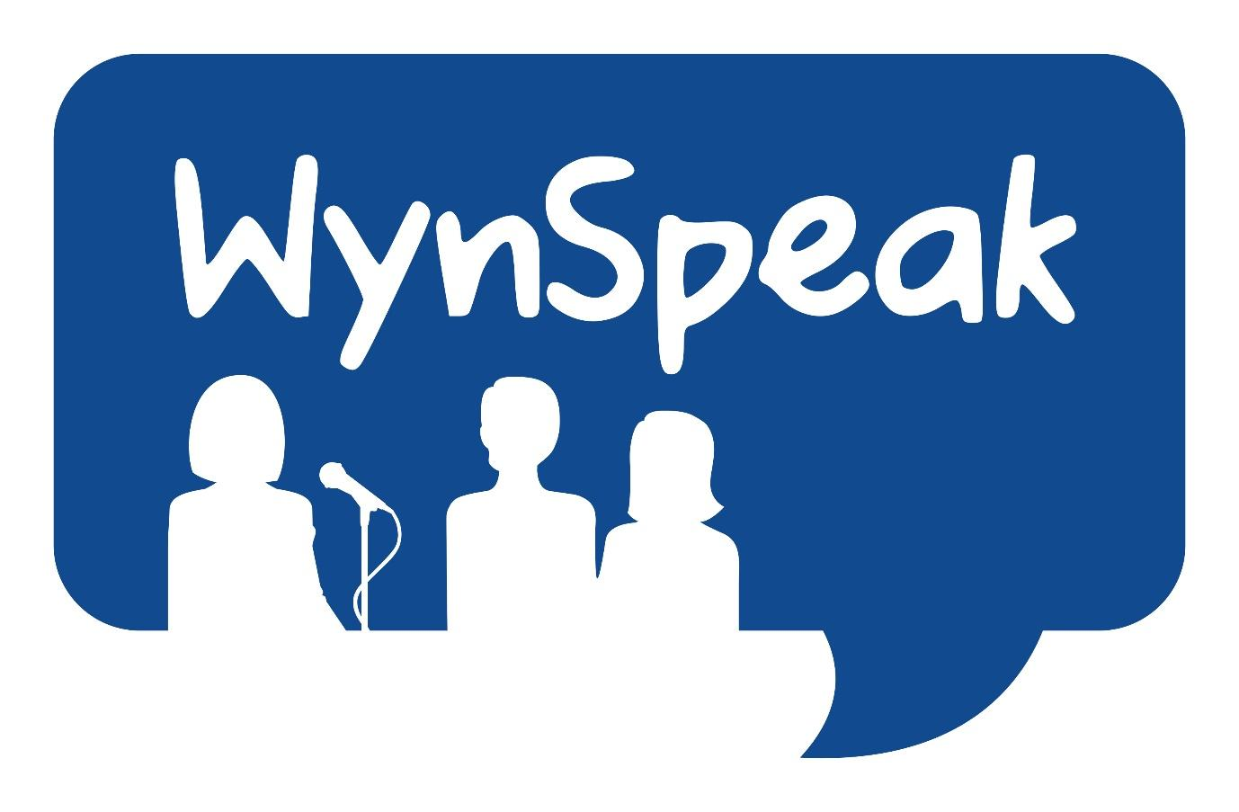  WYNSPEAK  Wyndham Youth Public Speaking Competition  - Post Office Box 1123, Hoppers Crossing VIC 3029  Email to desoshanassy@hotmail.com | 

Schools – Expression of Interest for the 2026 WYNSPEAK Competition

Important Information

The competition shall be run by ‘The WYNSPEAK’ Committee, an organisation formed in 2003 by the Rotary Club of Hoppers Crossing and the Hoppers Crossing Apex Club. The committee now comprises members from the Rotary Clubs of Hoppers Crossing, Altona City, Bacchus Marsh and Caroline Springs, past members of the Hoppers Crossing Apex Club with support from several Western Region Toastmasters Clubs. Also we have valuable support from our RYPA group of past competitors.

Eight preliminary rounds will be held next year, with five preliminary rounds to be held within the City of Wyndham, one preliminary round to be held in the City of Melton (Caroline Springs), one preliminary round held in Bacchus Marsh and one preliminary round to be held in the City of Hobsons Bay (Altona).

Schools may nominate a preferred date and/or venue. This choice will not be guaranteed but will be subject to demand, and/or order of entries received. The final decision as to which schools participate in each round will be at the discretion of the WYNSPEAK planning committee.

The competition final will be held at Thomas Carr College Performing Arts Centre on Wednesday June 3rd, 2026
‘The WYNSPEAK Committee’ will be solely responsible for the conduct of the competition, any governing rules, the adjudication of the competition and the declaration of finalists and winners.

The competition is open to all students attending secondary schools situated within the Western Region of Melbourne, or to those of secondary school age and entered by local youth organisations or alternative schools in the Western Region of Melbourne.

The competition shall be in two age groups; a junior section for students of school age corresponding to years 7-9, and a senior section for students of school age corresponding to years 10-12.
Each school may enter two students in the junior section and two students in the senior section of the competition. It is recommended that all schools select and submit details of reserve students who may be called into a preliminary round at short notice.

Please note details of all dates and venues will be provided to all colleges well prior to the commencement of the Competition.

Adjudication will be provided by appropriately experienced members substantially from Apex, Rotary &Toastmasters clubs.
Information about adjudication criteria, speech duration limits, warning bells, etc. will be provided to all schools in a student information pack prior to commencement of the competition.
All competitors will receive a certificate of achievement as an acknowledgement of their efforts and participation in the competition.
Winners of each preliminary round of the prepared speech competition in both the junior and senior sections shall receive a prize and proceed into the Final.
The Winners and Runners Up of the Final in each of the junior and senior sections will receive a cash prize and a trophy.
Prizes will also be presented to junior and senior section winners of the short notice speech competition during all preliminary rounds of the competition.
There will be no Short Notice Competition at the Final.
The schools or sponsor organisations represented by the winner of the prepared four-minute speech competitions in both the junior and senior sections of the competition will be presented with a perpetual trophy to be held for a period of twelve months.Where possible students will be scheduled to compete in venues other than their own school.

Note: The Junior and Senior winners of WYNSPEAK gain direct entry in the District 9800 Youth Public Speaking Championship to be held shortly after our event. Please be advised that entry into the WYNSPEAK competition is conditional on accepting the invitation to the D9800 Youth Public Speaking Championship

Competition Criteria

The competition shall consist of two separate sections as described below.

Section 1 – Prepared Speech Competition

In this section, the students are to prepare a speech of four minutes duration on a topic of their choice. Topics should not be of an offensive or divisive nature (eg. Religious, political, life choices) - if in doubt, the nominated teacher may refer the topic to the WYNSPEAK committee for clarification. The prepared speech should be the students’ own work, and should not be plagiarised from other sources or prepared by AI

Section 2 – Short Notice Speech Competition

In this section, the students are to deliver a short notice speech of 90 seconds duration on a random topic, provided to the speaker on the night, 90 seconds before speaking. This will be a totally separate competition and results of this section will not impact on the prepared speech competition. The structure of the speech should be similar to that in the four-minute speech competition. This will not feature at the Final.

Important information

The Junior and Senior winners of the WYNSPEAK 2026 prepared speech competition will gain automatic entry into the District 9800 Youth Public Speaking Championship and are expected to compete. This competition will be held in late June, 2026..

Special note:

We would appreciate receipt of your completed Expression of Interest form no later than 28th November 2025 so that your college can be guaranteed of a place in next year’s WYNSPEAK competition. Please note we will not be calling for student names until early in 2026.

If any of the school WYNSPEAK Coordinators will be departing their roles at the end of 2025 then we thank them for their support and invite them to inform us of their replacement’s contact details as soon as possible.

Important notice:
Photography and filming of students will not be permitted at the Heats. An exception may occur at Altona Civic Centre for sponsor photos with appropriate approvals.
Photography and filming will be allowed at the Final. For this to occur all Finalists must submit a completed parental permission form to the WYNSPEAK AT LEAST 5 DAYS PRIOR TO THE EVENT. Entry into the Final will be contingent on this form. The forms will be given to each finalist.

Prizemoney will be awarded directly into a nominated bank account, details of which should be provided to the organisers directly, or via school via the teacher/coordinator immediately following completion of the Final.

Trophies and Shields will be presented at the Final but must be returned to the organisers for engraving purposes. They will then be delivered to the winners’ school.

Special note pertaining to Wynspeak 2026

In recent years COVID issues have affected student availability to take their places in the heats, necessitating calls for standby students in unprecedented numbers. To address this issue for Wynspeak 2026 with the provision of a reserve student listing to be submitted with the student nomination form, there will be no limit set on the number of students nominated by schools in both the Junior and Senior sections, however student nominations should be listed in order of preference. The two senior and junior students listed on the student nomination form will gain automatic entry and those on the reserves list will accepted if opportunities arise.

The Committee will confirm which students will be selected for preliminary rounds, and, as indicated, the remainder will be invited to compete in the event of withdrawals or student shortages.

Progression to Final

Winners from each preliminary round will automatically progress to the Final only if there are a minimum of five seniors or five juniors competing in a preliminary round.

School Registration for 2026 WYNSPEAK Competition

If your school would like to participate in the 2026 WYNSPEAK competition, please complete the 1-page form below and return to the committee by 28th November 2025.

School/Contact Information

Name of School
Postal address
School phone no.
Name of School Principal

Important: Teacher nominated to co-ordinate the preparation for Competition - special note
This person will be the main liaison point for the organising committee and will be regularly contacted in the lead up to the competition regarding the general preparation and status of students participating in the competition.

Organising teachers name
Mobile phone number
Email address
Name of alternate teacher contact
Mobile phone number
Email address

Preferred date or preliminary round venue: (Not guaranteed) )

RSVP: 28th November 2025
Completed applications should be mailed to:

The Secretary
Organising Committee
Wyndham Youth Public Speaking Competition (WYNSPEAK)
Post Office Box 1123 Hoppers Crossing
Hoppers Crossing VIC 3029

OR

Scanned and emailed to: Wynspeak schools coordinator: desoshanassy@hotmail.com

