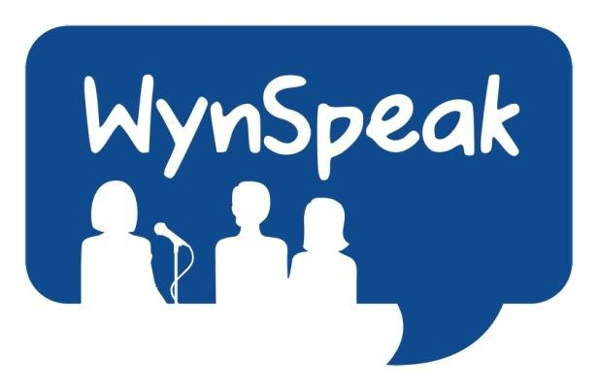
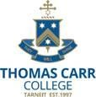Commences APRIL 27th 2023 Wyndham Youth Public Speaking Competition

Rotary Club of Hoppers Crossing

Supported by Rotary Caroline Springs, Melton and Altona City and Bacchus Marsh – assisted by Toastmasters International

A GREAT OPPORTUNITY TO REPRESENT YOUR SCHOOL AND WIN CASH PRIZES
If you would like the opportunity to display your skills in effective Public Speaking using a topic of your own choice and to meet likeminded students from 40 plus other schools - THEN WYNSPEAK IS FOR YOU!!

YOU, TOO, CAN JOIN STUDENTS FROM 40+ SCHOOLS THROUGHOUT THE WESTERN REGION AND GAIN GREAT EXPERIENCE IN THE SKILLS OF EFFECTIVE PUBLIC SPEAKING BY COMPETING IN THE LONG STANDING WYNSPEAK COMPETITION – NOW IN ITS 19TH YEAR
Junior Competition for years 7-9 students and
Senior Competition for years 10-12 students
Discuss now with your English Staff

